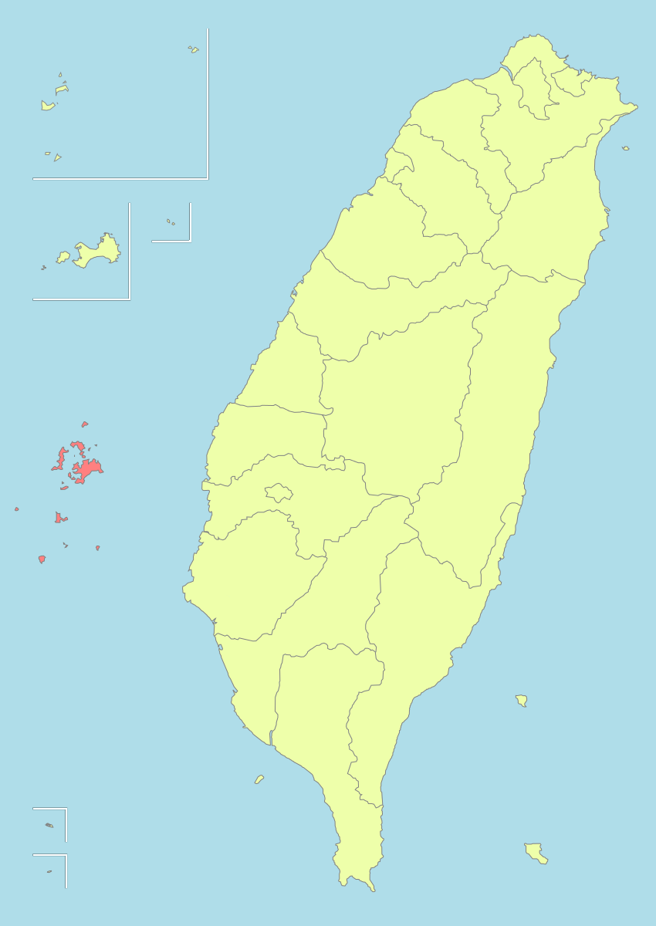
Inbound Field Trip-PengHu Invitation

Hey, inbounds. It is a great opportunity to explore the human culture and landscape of offshore islands in Taiwan, especially in summer time. Besides, we have a special night to watch the beautiful firework show. Welcome to join us!!

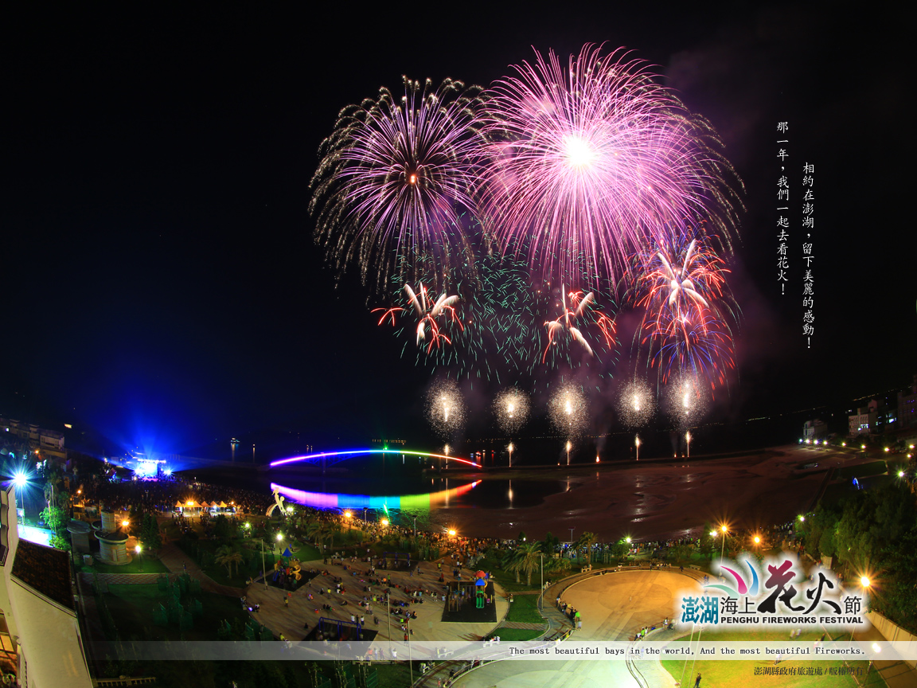
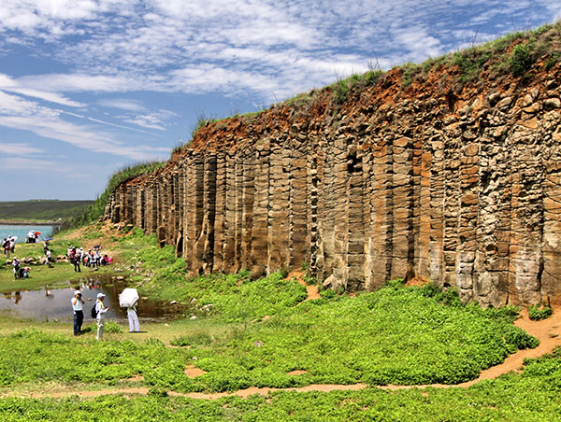

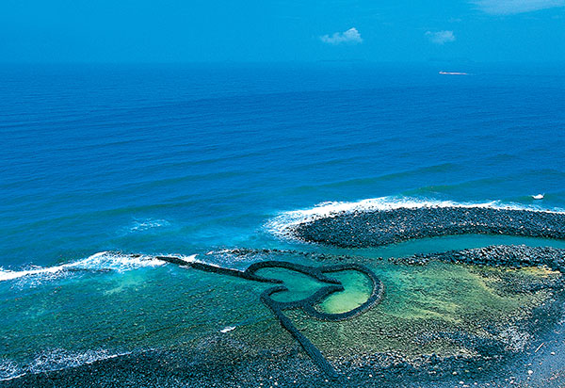

Date: May 4-6, 2015.
Registration: This is an optional activity. We provide 35 space for inbounds. To finish the registration, you must send the original Travel Rules Agreement to RYE office, and pay the tour fee 11,500 NTD to the RYE bank account before February 26, 2015.

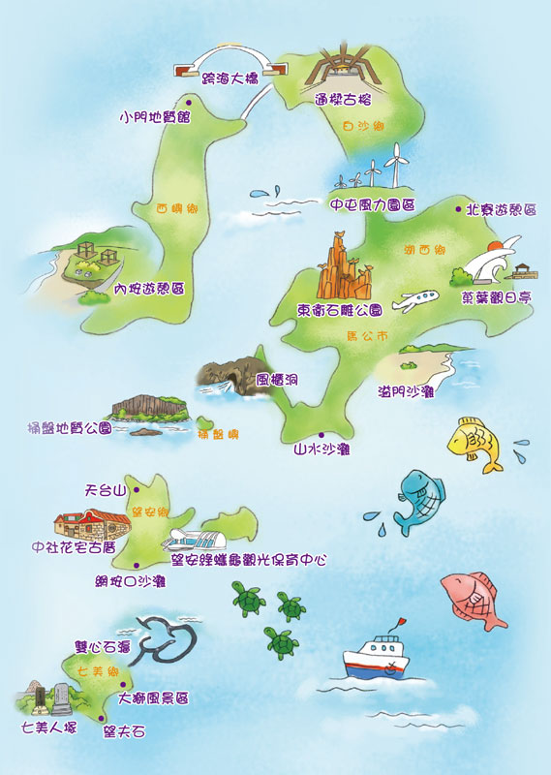

Itinerary: as attached file (More details will be notified after registration.)
Note: The tour is filled with seafood and boat transportation. If you are allergic to seafood or you are apt to get seasick, you may consider whether to join or not.

Call or mail to RYE office for more info…
2015 Inbound Field Trip-PengHu Itinerary
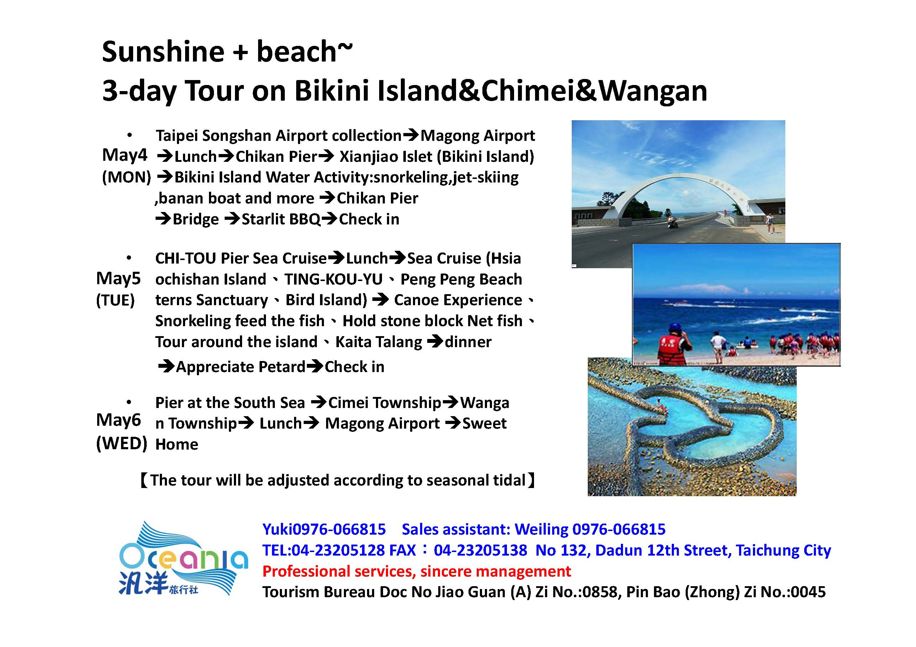

※The tour will be adjusted according to seasonal tidal

