L Learning Chinese！
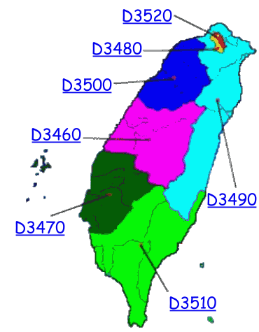

Now we are accepting applications for the 2015-16 School year.
( District 3460, 3470, 3480, 3490, 3500, 3510, 3520. R.I.)

The Rotarians of Taiwan, district 3460, 3470, 3480, 3490, 3500, 3510, 3520 Rotary International extend to you our warmest greetings and friendship. We request the cooperation of your district in a project designed to further international peace and understanding through acquaintanceship.

To further the International Service object of Rotary, we invite your district to submit to us a suitable student candidate from your community to be considered for an award of a scholarship under the Taiwan Rotary Ambassadorial Scholarship . This is not an exchange program, there is no financial obligation to the sponsoring Rotary district, and your district will not be obligated to accept a student from our country.

The Scholarship covers one scholastic year, from July 2015 to June 2016, and is for study Only in specified universities in Taiwan. The school to be attended in Taiwan will be selected by the Rotary District and processed admission by the Taiwan Rotary Ambassadorial Scholarship Program.

The scholarship pays all scholastic costs including tuition, book allowance, campus housing, and food. The Applicant must be at least 25 but not 40 years of age by August 1 of the year, they begin class. And those persons who have previously obtained the scholarship and studied in Taiwan cannot be considered.

It is permissible, that a candidate for one of the scholarships be a son or daughter of a Rotarian. It is of primary importance to select someone who would be a good "AMBASSADOR" of your country and Taiwan. We request that you give the program all the necessary publicity needed to secure
acceptable candidates.

Applications Due to October 31, 2014
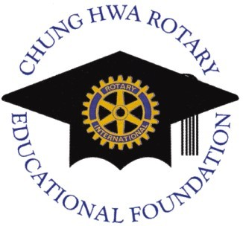

Chung Hwa Rotary Educational Foundation
Taichung , Taiwan /www.cref.org.tw/ E-mail：cref@ms29.hinet.net
Telephone：(866) 4-2328-2971/Fax：(866) 4-2328-2972
What Is The Taiwan Rotary Ambassadorial Scholarship？

Objects for the Taiwan Rotary Ambassadorial Scholarships

The Taiwan Rotary Ambassadorial Scholarships program supports the mission of The Chung Hwa Rotary Educational Foundation, to further world understanding and peace, by increasing awareness of Taiwan cultural to study in Taiwan.

Rotary Taiwan seeks out students who are interesting in Taiwan cultural for the challenge of serving as outstanding ambassadors of goodwill. Candidates should major the Mandarin Chinese Language and Taiwan culture at least 3 courses in the Scholarship year.

Scholarship Covers one scholastic year, from July 2014 to June 2015 , and is for study only in specified universities in Taiwan.

Scholarship Pays for airfare, tuition, book allowance, meals, college provided room, NT$25,000 each month to cover personal items.

Eligibility Requirements, 25-40, graduate from college or university, Must have a recommendation by a Rotary District Governor for a scholarship. can be son/daughter of a Rotarian, but a Chinese, or Chinese's direct descendant is not eligible for scholarship.

Schedule for the Scholarship Works：

1、Submit required document to the sponsor Rotary District before September 30.
2、Applicants shall be chosen from the Sponsor District before October 31.
3、Applicants shall be chosen from the Host District before November 30.
4、The Board Meeting of the Chung Hwa Rotary Educational Foundation Will be held on the end of the December 24, And Announcement the Scholars' Name.
5、Make yourself available for school Application before the Rotary year.

Taiwan Rotary Ambassadorial Scholarship
(Application Form for RY. 2015-2016 )

Applications must be made through a local district, application submitted
directly to the CHREF will not be considered. And, before completing
this application, you must to ensure that you can meet local application
deadline. Please type in print alphabet, if possible, Do not use initials or
abbreviations.

Name in full：

Family Name First, Middle, and Other Names

Nationality year of Birth □ Male □ female

Permanent Mailing Address

Country /Post code/City/ Town /State/ Province

Telephone /E-mail / Fax /Address where mail will reach you before and after your scholarship

Emergency contact：Name/ Relationship /Telephone/ E-mail

Proposed field of study for the award：

Name of institutions for study city and university that you choice
1、
2、

Statement of Purpose /Study Play

PERSONAL INFORMATION

Educational History
Postsecondary or university level (list planned or most recent studies first： Names of institution/city/town/State/Province/Country/Dates attended/Field of Study/Specify Degree or Received or Expected)

1、
2、
3、

Work Experience： (Full-Time Employment History)
List current or recent first (Name of employer/ type of work /dates worked)

1、
2、
3、

Skill and Language Capabilities

1、
2、
3、

Previous Experience Abroad
Please list all countries in which you have previously lived or studied for more than one month after the age 10. Include any countries in which you plan to live or study after application but before the 2015-16 study year.)
1、
2、
3、

An Application materials must include﹕

1、Completed Application Form due to September 30.
2、A recommendation by a Rotary District Governor for a scholarship.
3、Two (2) letters of recommendation from different teacher or an employer.
4、Official transcript in English of each year attended in your final school , or currently under study.
5、Brief Essay by yourself with A recent headshot photo in .
6、Health Certificate (within the past 6 months)
※ Once submitted, none of these materials can be returned or copied.※
What the students should know：

1、The successful applicants should actively involved with his/her sponsor Rotary club and Rotary district during his/her stay in Taiwan.

2、The student should submit on time a written report on what he/her had learned during the studying period to the sponsor club and this Foundation; also should present a oral report & a regular meeting of the sponsor Rotary Club upon completion of his/her study in Taiwan.

3、Keep communication with your sponsor and host Rotarian before, during, and after your study period. To offer to share your ambassadorial
experience at Rotary club or district meeting.

4、The student is responsible for all necessary insurance during his/her stay in Taiwan.
5、Registering contact information with alumni relations at the Chung Hwa Rotary Educational Foundation, keeping your address, telephone number, and e-mail address updated at all times.
6、Any behavior of the student that may damage the reputation of the Rotary Clubs or termination prior to the end of the study program for any reason will result in the cancellation of all rights and qualifications for the scholarships.

Each scholar will be paired with one district and study at the university list as following：

Host District | Assigned University | Location in
3460 | National Chung Hsing University | Taichung, Taiwan
3470 | National Cheng kung University | Tainan, Taiwan
3480 | National Taiwan University | Taipei, Taiwan
3490 | Fu Jen Catholic University | Taipei, Taiwan
3500 | National Ching Hwa University | Hsing-chu, Taiwan
3510 | National Sun,Yat -Sen University | kaohsiun, Taiwan
3520 | National Normal University | Taipei, Taiwan

It is the students responsibility to register by yourself , Immediately upon deciding to submit the application , no later than May 1 of the year you apply. Failure to register will result in your not being eligible to receive a scholarship. (※A copy of personal data should be provided to this foundation.)

Applicant's Signature
Date﹕

District Application for Taiwan Rotary
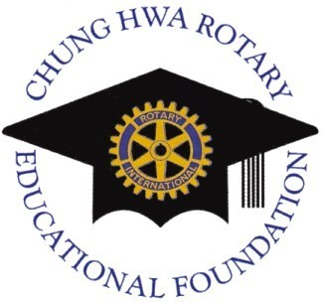
Ambassadorial Scholarship (2015-2016)

District No. Nationality This Application is for Taiwan Rotary Ambassadorial Scholarship of Chung Hwa Rotary Educational Foundation

1、Donor Contribution：Chung Hwa Rotary Educational Foundation, Which was established by donation from 23,000 Rotarians in Taiwan , makes a contribution to Rotary Foundation.

2、Contact：The District that Scholars will be paired and study at the institutions directly or to Chung Hwa Rotary Educational Foundation .

3、Host District：Each Rotary District located in Taiwan (3460, 3470, 3480, 3490, 3500, 3510, 3520)
4、Scholarship Type：1-Year of Ambassadorial.
5、Scholarship year： 2015-2016

Although the Board of The Chung Hwa Rotary Educational Foundation reserve the right to determine which districts will be pared in 2015-2016 year, applying districts may list 1st, 2nd, 3rd, choices of districts which they would like to be paired with. If two districts list each other as first choice by prior mutual consent, in most instances, the Trustees will grant that request.

□ 1st preferred district Reason
□ 2nd preferred district Reason
□ 3rd preferred district Reason

Further, on behalf of this district, we agree to the following as indicated. (Please check appropriate space.) If the Trustees are unable to pair our district with any of three preferred districts listed above, this district：

- will accept a pairing with any district selected by the trustees;
- will NOT accept a pairing with a district other than those listed above and will consider this application null and void if such pairing cannot be made;

After interviewing this candidate, We submitted this endorsed applications for this Scholarship , Who appreciates and want to learn Mandarin Chinese and know more about Taiwan.

Name of 2014-15 District Governor（Please print）Name of 2015-16 District Governor

Signature of 2014-15 District Governor Signature of 2015-16 District Governor
We, Rotarian Care The New Generation
(※The Chung Hwa Rotary Educational Foundation※)

The Chung Hwa Rotary Educational Foundation was established on February 23, 1975 for celebration of R .I .' s 70th Anniversary .The inauguration of the foundation was based on provision of the "District Rotary-Sponsored Activities" in R. I. Manual of Procedure, and had been agreed by all Rotarians in Taiwan .

Purpose：
Base on the spirit of Rotary service and through the proper use of the fund to promote education, research, and invention , to encourage the specialists and
scholars and scholars of this country to devote themselves to research and invention, and promote the understanding and friendship of people in different countries.

Organization：
The Board of Directors composes of 28 members, With a rule by all the District Governors and Governors – Elected in Taiwan . After PDG.Cal（D-3480）、PDG. Derma（D-3460）、PDG. Micro（D-3460）、PDG. Right（D-3480）, PDG. Wood（D-3460）, PDG. Kent (D-3470) ,The Chairman is the Past District Governor of District 3490：Dai- Ming , Kuo .（PDG. Trading）Currently.

Resource of the Fund：
The resource of the fund is collected from Rotarians in Taiwan and others by free contribution.

Academic Scholarship of CHREF﹕

1、Since 1976, the award has been contributed to 127 foreign students from 16 countries who studied in Taiwan; 14 college students who devoting themselves in significant service; 9 persons who devoting themselves in education for the disable; 20 overseas Chinese students; 35 Chinese refugees from northern Thailand who studying in Taiwan and 3 special researchers in medicine.

2、The award has been contributed to the scholars who studding in
Taiwan , since 1986,and has assisted 1036 doctoral candidates and 2,163 students in the master's degree program to complete their studies. Each doctoral candidate on the Scholarship list receives NT＄160,000 and each recipient in master's degree program receives NT＄120,000. each year.

3、The foundation operate a program , named Taiwan Rotary Ambassadorial scholarship, for foreign students to learn mandarin Chinese in Taiwan, And since RY 2004-05 until 2013-14 has assisted 20 Scholars the Ambassadorial Scholarship , Include 3 Ambassadorial Scholarship this rotary year .

