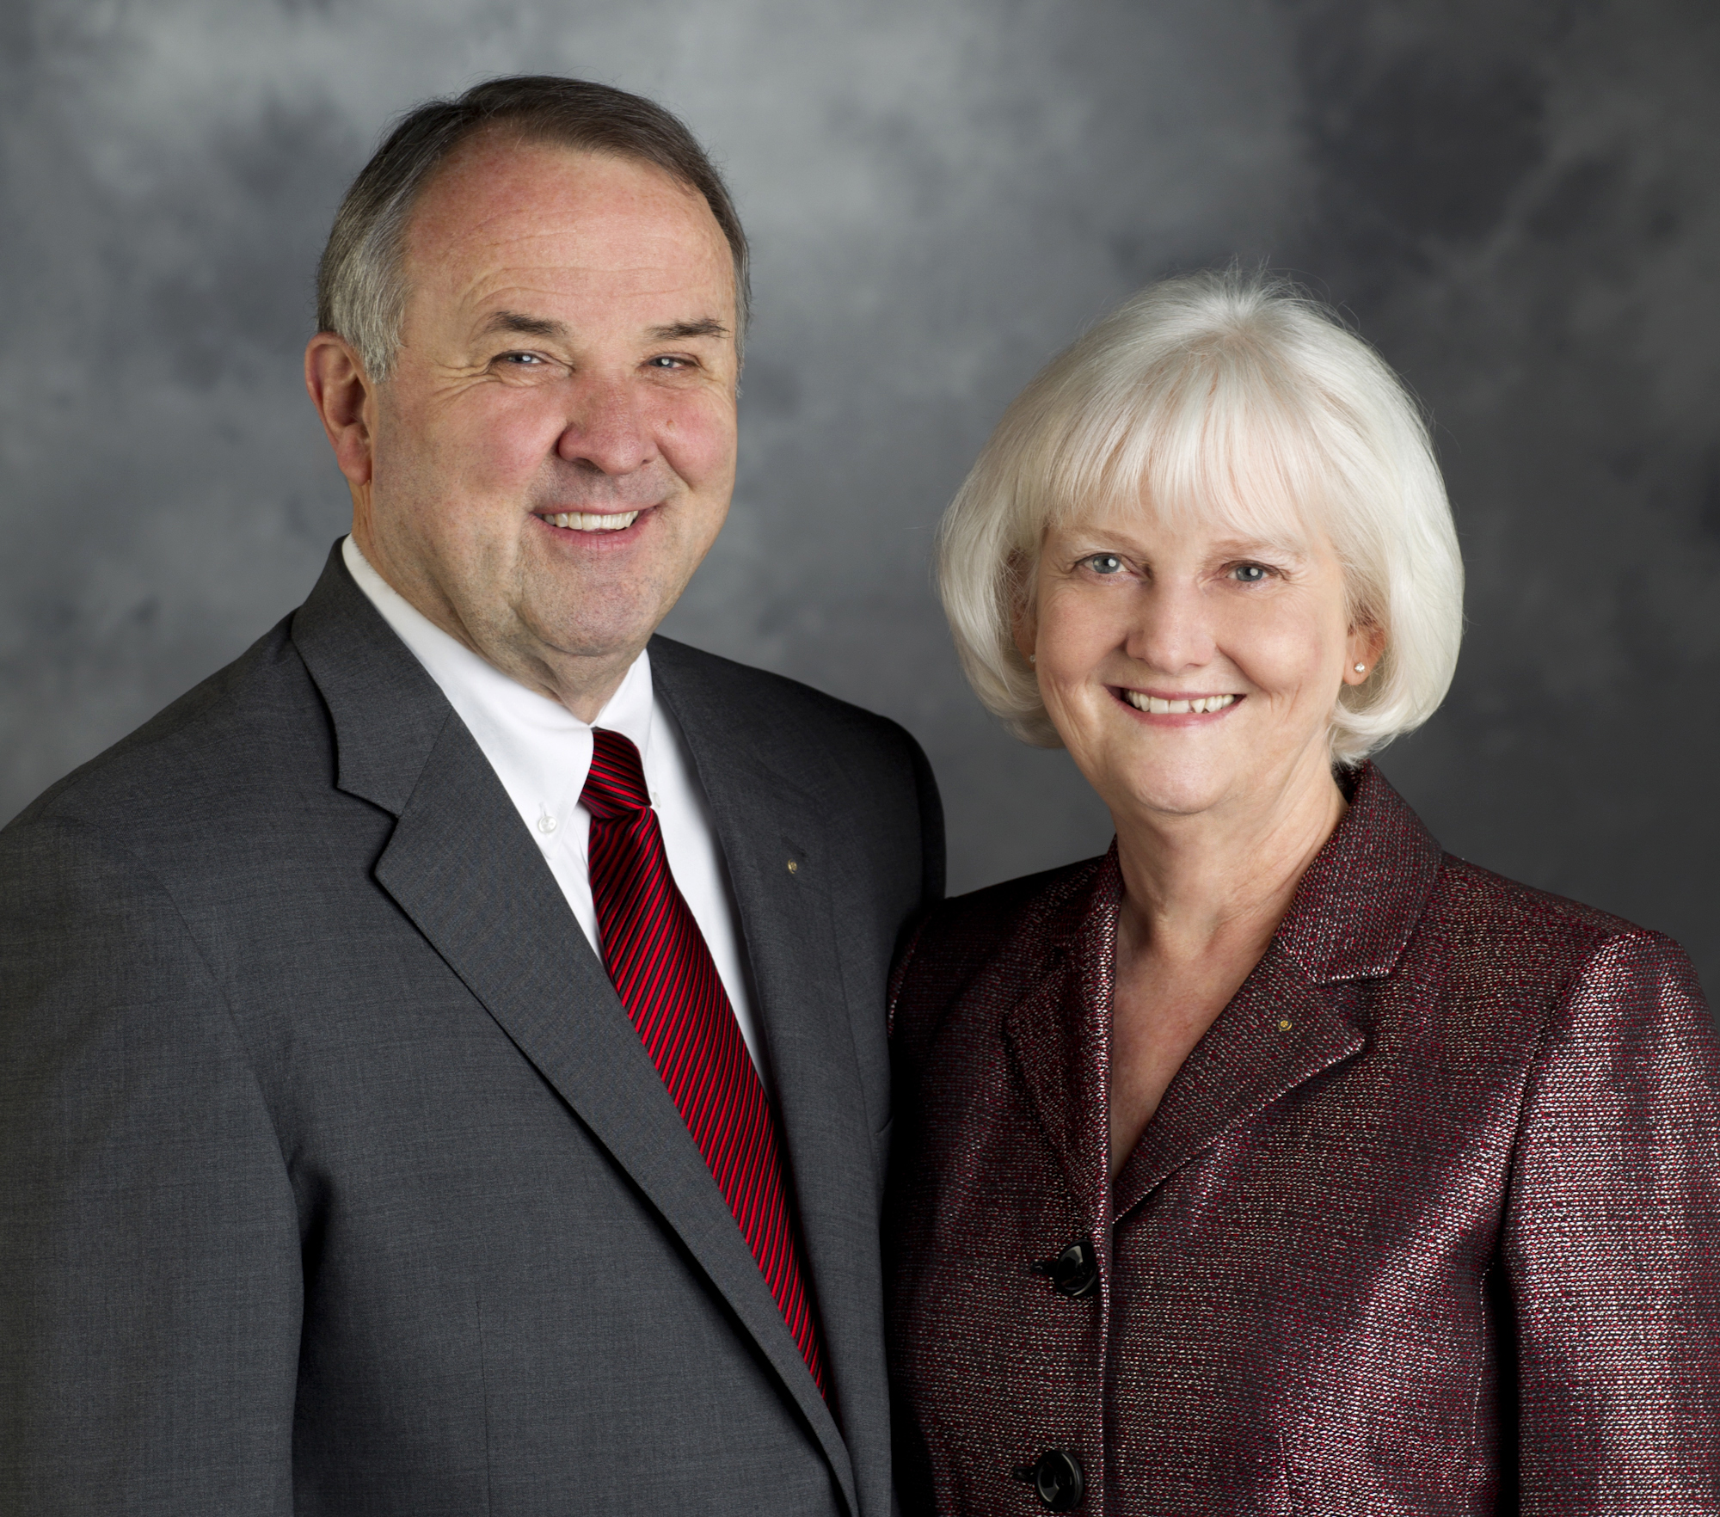
朗‧伯騰Ron D. Burton
國際扶輪社長 (2013-14年度)
國際扶輪理事 (1998-2000年)
扶輪基金會保管委員會副主委 (2008-09年
度)及委員 (2006-10年)

伯騰原來擔任奧克拉荷馬大學基金會會長，於2007年退休。他是美國最高法院律師協會、克里夫蘭郡律師協會及奧克拉荷馬州律師協會的會員。他也是美國律師協會聯會(ABA)、ABA免課稅組織委員會組、ABA慈善組織不動產、遺產認證及信託委會員組的會員。他是美國童軍協會最後邊疆分會的前副會長，曾榮獲銀狸獎。他也曾榮獲諾曼聯合勸募及小聯盟年度義工市民獎。
伯騰自1979年成為扶輪社員，是美國奧克拉荷馬州諾曼扶輪社社員。他曾擔任國際扶輪的地區總監、立法會議代表(1992年及1995年)、國際扶輪講習會小組討論領導人及主席、地帶訓練師、扶輪知識顧問、特別工作小組及委員會委員、國際扶輪社長代表及國際扶輪社長侍伴。他曾任2011年紐奧爾良年會委員會主委。
擔任理事期間，他曾任執行委員會、行政管理委員會及審計委員會主委。
此外，他曾任扶輪基金會的發展委員會顧問、永久基金行動全國顧問、地域扶輪基金會協調人、國際根除小兒痲痺等疾病委員會委員、永久基金領導團隊委員、根除小兒痲痺等疾病演講人團團員及地域扶輪基金會協調人訓練計畫主席。他在2006-10年擔任保管委員並在2008-09年度擔任保管委員會副主委。他也曾擔任未來願景計畫委員會委員及副主委。
在2013-14年度，朗．伯騰Ron D. Burton將擔任國際扶輪社長。
伯騰曾獲頒國際扶輪的超我服務獎及扶輪基金會的有功服務獎及特優服務獎以及無小兒麻痹世界國際服務獎。他與夫人潔妲Jetta是保羅哈理斯之友、永久基金捐助者、巨金捐獻人及扶輪基金會的保羅哈理斯會、遺贈會及阿奇柯藍夫會會員。

Ron D. Burton
RI President (2013-14)
RI Director (1998-2000)
Rotary Foundation Vice Chair (2008-09) and
Trustee (2006-10)

Ron D. Burton retired as president of the University of Oklahoma Foundation Inc. in 2007. He is a member of the U.S. Supreme Court Bar, the Oklahoma Bar Association, and the Cleveland County Bar Association. He also is a member of the American Bar Association; the ABA Section of Taxation Exempt Organizations Committee; and the ABA Section of Real Property, Probate, and Trust Committee on Charitable Organizations. He was vice president of the Last Frontier Council of the Boy Scouts of America and received the Silver Beaver Award. He also received the Norman United Way and Junior League Volunteer of the Year Civic Award.
A Rotarian since 1979, Ron is a member and past president of the Rotary Club of Norman, Oklahoma. He has served RI as district governor, Council on Legislation representative (1992 and 1995), International Assembly group discussion leader and moderator, zone trainer, Rotary information counselor, committee and task force member, RI president’s representative, and aide to the RI president. He also chaired the 2011 New Orleans Convention Committee.
As a member of the Board of Directors, he served as chair of the Executive Committee, Administration Committee, and Audit Committee.
Additionally, he has served The Rotary Foundation as a consultant to the Development Committee; national adviser for the Permanent Fund Initiative; regional Rotary Foundation coordinator; member of the International PolioPlus Committee, Permanent Fund Leadership Team, and PolioPlus Speakers Bureau; and moderator of the regional Rotary Foundation coordinator training program. He served as trustee in 2006-10 and vice chair in 2008-09. He also has been a member and vice chair of the Future Vision Committee.
In 2013-14, Ron will serve as president of Rotary International.
Ron has received the RI Service Above Self Award and the Foundation’s Citation for Meritorious Service, Distinguished Service Award, and International Service Award for a Polio- Free World. He and his wife, Jetta, are Paul Harris Fellows, Benefactors, Major Donors, and members of the Paul Harris Society, Bequest Society, and Arch C. Klumph Society of The Rotary Foundation.

