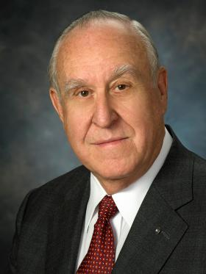
國際扶輪社長當選人
澤恩John F. Germ
2016-17年社長
美國田納西州的查坦努哥扶輪社

澤恩是坎貝爾聯合工程顧問公司的董事長暨執行長。他在美國空軍服役4年後，於1965年進入該公司擔任工程師。他曾在數個組織的理事會服務，包括公共教育基金會、橘林殘障服務中心、及安全供血中心。他是查坦努哥州立科技社區大學基金會的創辦人兼財務長，也是田納西州青商會會長。

澤恩自1976年加入扶輪成為扶輪社員迄今，曾擔任國際扶輪副社長、理事、扶輪基金會保管委員及副主委、扶輪基金會保管委員會主委特助、扶輪2億美元挑戰委員會主委、國際扶輪理事會執行委員會委員、國際扶輪社長特助、社員地帶協調人、委員會委員及主委、特別工作小組地帶與區域協調人、國際扶輪訓練領導人及地區總監。

澤恩曾獲頒國際扶輪的超我服務獎及扶輪基金會的有功服務獎及特優服務獎。他與夫人茱蒂Judy都是阿奇‧柯蘭夫會會員。

RI PRESIDENT-ELECT

JOHN F. GERM

PRESIDENT 2016-17

ROTARY CLUB OF CHATTANOOGA

TENNESSEE, USA
John F. Germ is board chair and chief executive officer of Campbell and Associates Inc., consulting engineers. He joined the firm as an engineer in 1965 after four years in the U.S. Air Force. He serves on the boards of several organizations, including the Public Education Foundation, Orange Grove Center Inc., and Blood Assurance Inc. He also is founder and treasurer of the Chattanooga State Technical Community College Foundation and president of the Tennessee Jaycee Foundation.
Germ joined Rotary in 1976 and has served as RI vice president, director, Foundation trustee and vice chair, aide to the Foundation trustee chair, chair of Rotary’s US$200 Million Challenge, RI Board Executive Committee member, RI president’s aide, membership zone coordinator, committee member and chair, task force zone and area coordinator, RI training leader, and district governor.
Germ is a recipient of RI’s Service Above Self Award and The Rotary Foundation’s Citation for Meritorious Service and Distinguished Service Award. He and his wife, Judy, are members of the Arch Klumph Society.

